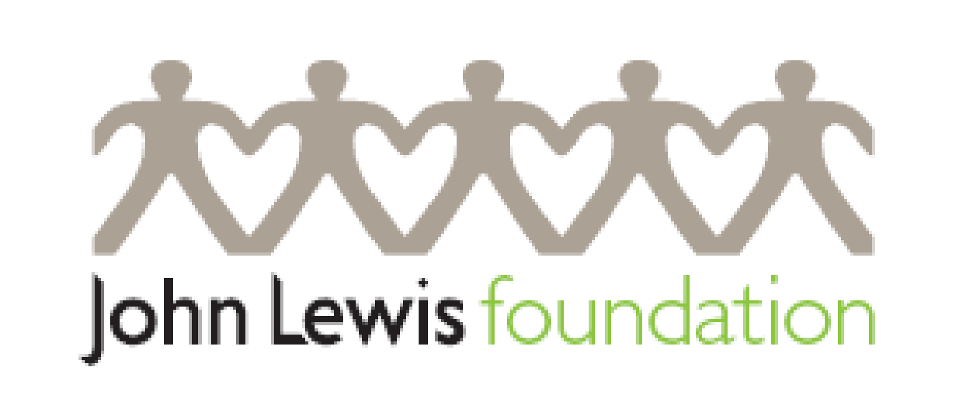
Application for funding
Guidance notes for applicants are available online at www.johnlewisfoundation.org
Please ensure the application is signed and dated and includes all necessary supporting documents.
Applications should be submitted online to johnlewisfoundation@johnlewis.co.uk

Section 1 - about you and your organisation

Name of your organisation:

Postal address:

Phone: Website:

Name of contact and their title:

Phone: Email:

Names and titles of all responsible Directors and/or Trustees:

Please indicate any connection you, your organisation, or any individual within your organisation has with the John Lewis Partnership.

Registered charity number:
If you are not registered, please clarify your charitable status.

Legal status of your organisation and Company registration number:
i.e. Company limited by guarantee, Community Interest Company etc.

What is your organisation’s annual gross income?

Please indicate which of the below best describes you or your organisation:

John Lewis Partner John Lewis Supplier

Independent UK Charity Independent Overseas Charity

Community Interest Company

Please indicate all that apply to your organisation:

Education Social inclusion Community Activities

Training/skills Environment Other (describe)

Please tell us about your organisation’s mission or overarching objectives, and how they meet the Foundation’s funding criteria.

How did you hear about the John Lewis Foundation? i.e. word of mouth, internet, in-store poster ...

Section 2 - about your project or initiative

Please give a brief outline of the project or initiative for which you’re seeking funding, mindful that the Trustees are currently focusing on projects which promote training that leads to meaningful employment. Please also include a clear illustration of how any grant money would be spent. See the Applicant Guidance Pack for help.

How much are you applying for?

Please detail below any funding you’ve already secured for this project.

Will the project offer any volunteering opportunities for John Lewis Partners? If so, please outline what these might be.

Would you be happy for The John Lewis Foundation to publicise their involvement with this project? Yes No

Name of PR contact: Email:

Phone:

Please tell us how the project will be managed. See the Applicant Guidance Pack for help.

Who will benefit from your project or initiative?

How will you measure the success of your project? The Trustees are interested in details such as the metrics you will apply, the evaluation and reporting frameworks, and the time periods etc. Please list a minimum of three. These metrics will be used to measure the success of any project the Trustees elect to fund. See Applicant Guidance Pack for help.

Objective | Output | Outcome

Section 3 - supporting documents
In order to be considered, all applications must be accompanied by the following supporting documents:

- Your organisation’s most recently audited accounts
- An income and expenditure schedule for the current year + a detailed breakdown of how any grant from the Foundation will be disbursed if not included Section 2 above
- Written confirmation signed by the Chief Executive Officer of your organisation confirming that DBS checks (PVG checks in Scotland) have been and will be carried out on all staff or volunteers working with children or vulnerable adults. If your organisation is exempt from these checks, please give a detailed explanation for the exemption, signed by the Chief Executive Officer
- A copy of your organisation’s Whistleblowing Policy and of its Safeguarding Policy signed by the Chief Executive Officer guaranteeing the policies are ’current and effective’.
- A copy of your organisation’s Anti-Slavery Policy. If your organisation does not have an Anti-Slavery policy, and is not required to have one by law, please sign the Statement below
- Any other information you would like to include in support of your application. This additional information must be no more than two sides of A4

If you have any queries regarding your application, or any further questions about how to apply, please contact johnlewisfoundation@johnlewis.co.uk.

have one, and is not required by law to publish one, please sign the Anti-Slavery
Modern Slavery
As part of the conditions of making a donation or offering a grant to any charity, the John Lewis Foundation requires an agreement or statement on Modern Slavery.
If you have a Modern Slavery Statement please include it in your application pack.
If you don’t have a Modern Slavery Statement, and are not required to have one by law, please complete and sign the declaration below.
To find out if you’re required to have a Modern Slavery Statement by law please visit: www.gov.uk/government/publications/transparency-in-supply-chains-a-practical-guide

Some useful contacts for information on Modern Slavery, and where to find advice and awareness training:
www.stopthetraffik.org
www.unseenuk.org
www.stronger2gether.org
www.hopeforjustice.org
Please note this list is not exhaustive.

Modern Slavery Declaration
Our organisation _________________________ is not required by law to have its own Modern Slavery Statement. We undertake to abide by the John Lewis Foundation commitment to Modern slavery.
We can confirm that:
- All staff and volunteers who work with us have been trained to understand what Modern Slavery is, how to identify it and how to report it.
- Information on Modern Slavery is shared with our beneficiaries and clients in a language they can understand as part of their safeguarding training.
- All members of our supply chain have been subject to due diligence to ensure they:
understand what Modern Slavery is, how to identify it and how to combat it
operate robust recruiting policies in line with UK employment law
offer market related pay
provide wellbeing activities which support the mental and physical wellbeing of all staff

Signed______________________________________ Chair/CEO of___________________________

Section 4 – declarations

I confirm that all the information included in this application is correct. Knowingly providing false information will invalidate your application and nullify any offer of funding that may have been made on the basis of this document.

Signature: _______________________________ Date: _____________

Name and position held: ________________________________________________

Data protection:
John Lewis and Partners and the John Lewis and Partners Foundation comply with GDPR regulations that came into force in 2018. We are committed to protecting your privacy and will ensure all data we receive is handled correctly. We will use the data you have provided to:
- assess applications
- monitor grants and projects
- evaluate the effectiveness of our grant making process
- report to Government and government organisations as required
- meet our audit and other reporting obligations as required by law
- inform Partners of volunteering opportunities within your organisation

We will also use the information provided to conduct identity checks and follow compliance procedures prior to releasing funds.

