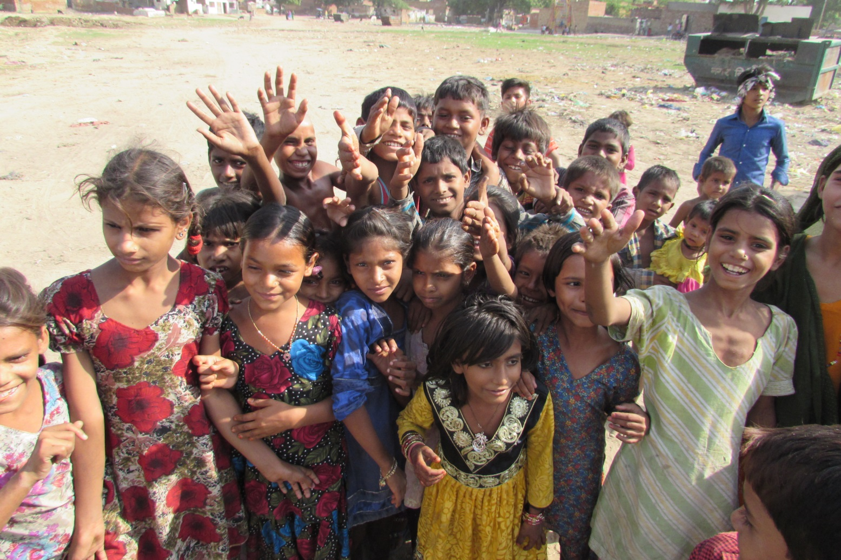
THANK YOU FOR YOUR SUPPORT

Over the last six months the John Lewis Foundation have kindly supported Toybox’s work with street and working children in India. The following report is an update on the project’s progress showing each of the objectives in the proposal and their outcomes so far.
Project Summary: Street to School - India
Education is the single most effective way of breaking the cycle of poverty that street and working children in India experience. Many children in Delhi have not been able to attend school before, either because they have to work to support their families, or through lack of the correct legal documentation required to enrol.
One of the obstacles to school attendance is lack of understanding amongst families on the importance of education, particularly if this is the first generation of children with the opportunity to do so. Therefore, one of the first steps that the project takes is to work closely with parents to inform and encourage them to send their children to local schools.
Education clubs are set up under trees and in other communal places within the community to enable the children to start some informal education as they journey to be enrolled in school, but also to help those in school catch up and keep up with homework.
However once street children do enrol into school, they still face many unique challenges. This project will help children overcome the barriers to their education by providing training to teachers and pupils to improve perceptions and treatment of street children. It will also engage with government schools and authorities to improve the access, retention and completion of basic education of street and working children in Delhi.
Objective 1 - Improved parental understanding on the importance of education and sending their children to school
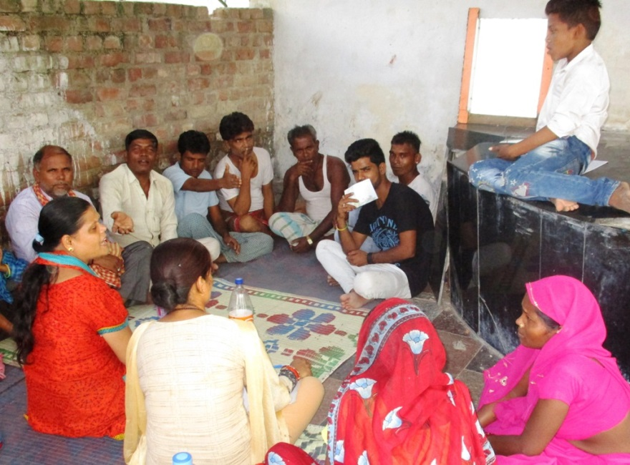
At the beginning of the project parents meetings were organised at the same time as the children’s education clubs to create an opportunity to engage with parents to discuss enrolling their children in school and some of the challenges with this process. The team also talked to the parents about the Parent and Teacher meetings (similar to PTA’s in the UK) and the School Management Committee’s they could join. The parents were strongly encouraged to ensure their children attend formal school as well as the education clubs. Within three months 64 parents were attending the Parent and Teacher meetings and 9 of the parents had become members of the School Management Committees. The project parent’s meetings are now held once a quarter.
Over the past six months there have been four community awareness rallies to create awareness about the importance of children having an education. The children in the education clubs take part in the rallies as well as children and teachers from the local schools who have become advocates for street and working children attending school.
Objective 2 - 500 street and working children in Delhi are enrolled into formal education and demonstrating active attendance
There are now 13 education clubs running across the project area. During the first three months of the project 273 children were enrolled in school for the first to join the 240 already registered and part of the project.
During the education clubs some of the children who show leadership qualities have taken on the role of peer supporters for the children new to the education clubs and enrolment in school. They spent time helping the new children by discussing the importance of education, regularly attending school and issues around child rights

A residential workshop for children was organized for 30 children to attend for five days in October 2016. This was an enriching experience for children, where they engaged in a variety of group activities. They had a lot of fun as well as learning about team work, how to express themselves creatively and it different ways along with what it means to be a peer mentor and a good leader. When the children got back they presented everything they had learnt to the children in their education clubs and have subsequently started up groups to peer support the other children and continue to encourage them to attend school. They benefited greatly from the residential workshops.

Part of the street educator’s role is to conduct home visits on a regular basis to ensure the children are attending school and helping to find out early if there are issues stopping the children from going to school. This regular presence has also helped to build stronger relationships with the parents and enabled the street educations to break down any barriers being faced by the children in terms of their education as well as identify any issues of abuse.

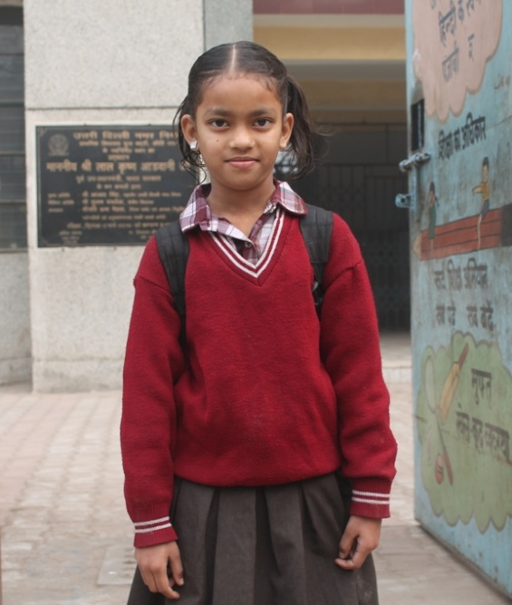
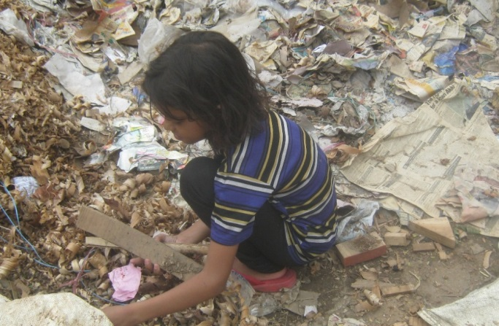
10-year-old Nalini scarcely went to school. She has dyslexia and kept getting her words wrong in class. Her teacher scolded her. Her classmates made fun of her. Feeling alone and useless, this little girl dropped out of school completely… and into a life of unimaginable danger.
“When I found Nalini, she was severely malnourished and picking up nails by the railway tracks,” says Geeta, a street educator with our ‘Street to School’ project in Delhi. “Children can make a few rupees by collecting nails and wood shavings from the nearby factory. But trains thunder by just inches from where they’re crouched on the ground.”
Geeta was determined to rescue Nalini from this horror. She worked hard to enrol her in a new school, convincing the teachers that Nalini was ready and eager to learn. She helped Nalini with her homework and accompanied her to class every day, making sure this little girl didn’t drop out of school again.
The pictures opposite show Nalini before and after starting school

Objective 3 - There is visible change in the current preconceptions held by teachers, pupils and authorities about street and working children

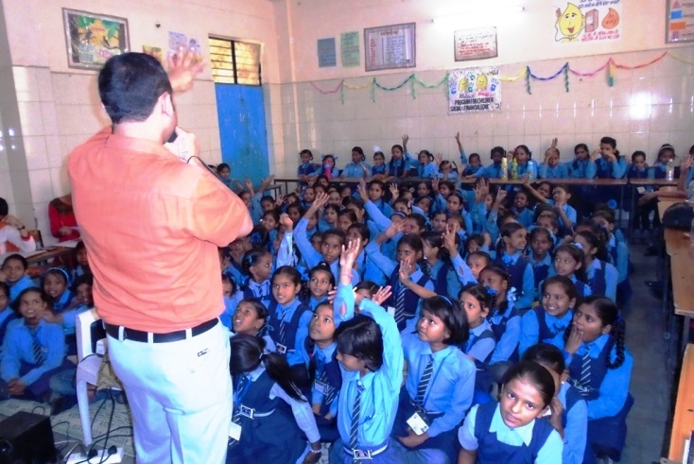
Life skills workshops have been organised in several of the schools with students from the 4th and 5th grade. Many topics are covered including child rights and child protection.
The giant wall magazine has been created and updated in most schools. The team facilitated the creation of the display that cover some of the topics the children have been learning about including child rights, health and hygiene. The children feel they have a public voice in the school setting which is very empowering.
There have been a variety of meetings with local government officials over the last six months including the National Commission for Protection of Child Rights and staff from the Education Department. These meeting ensure the local stakeholders are aware of the ‘Street to School’ project and the success of integrating street and working children back into state schools. The meetings were also an opportunity to advocate for the Education Department to adopt the strategy of working with street and working children in this way. The response at each meeting has been very positive and more are planned for the future.
Teacher training was organized with teachers in several of the participating schools. The team worked with the teachers to decide on the topics covered. The first session covered Child Rights, then how to help abused children and the third was about the right to education. The teachers have commented that they haven’t ever had training like this before and some said that they training had made a difference in their personal as well as professional lives.
As always there are some challenges and a couple the team have encountered include:
The Street Educators often support the children in the education clubs in a variety of ways as they encourage them discipline them and care for them. A social worker on the team would be a great benefit to enable the educators to focus on education.
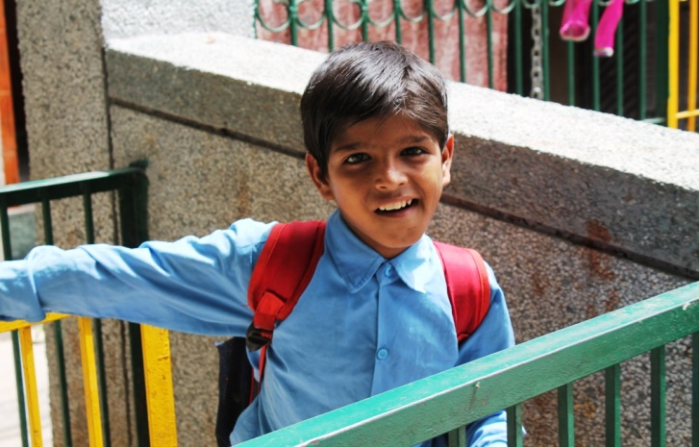
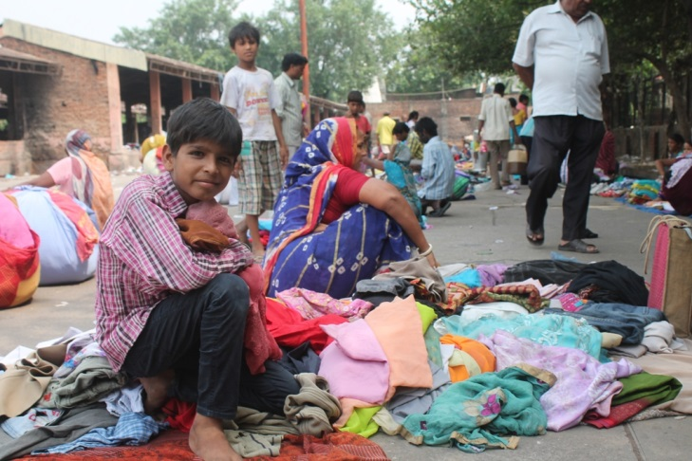
The project is proving to be so popular and successful with helping children to start and stay in school that parents approach the team on a regular basis asking if their children can be part of the program. They have many additional children just joining the education clubs as they are so desperate to learn. It’s great that the project is a success but due to staff capacity and resource the street educations are not able to support many additional children as well as keep up the focus on those that are part of the project already. It does show how the project could be expanded in the future.
Thank You John Lewis Foundation for partnering with Toybox to truly change the world for street children
Kamlesh
Ten-year-old Kamlesh has an unimaginable life for a child. At 3am, he wakes up and rushes to the cloth market to start work. There, he crouches for the next nine hours, separating different types of rags and pieces of clothing to be sold. At midday, Kamlesh finishes an exhausting morning’s work. Then he picks up his books and goes to school.
Thanks to Sharda, the street educator who enrolled him, Kamlesh is able to go to school for a few hours before he returns to work in the cloth market in the evening. “Sharda helps me with my homework after class,” says Kamlesh. “So I don’t fall behind the rest.”
Kamlesh has to work incredibly hard to support himself. But thanks to our ‘Street to School’ project, he’s now going to school and giving himself the chance of a better future. In fact, Kamlesh is determined to own his own garment factory one day.
“He’s is one of the smartest kids I’ve seen and someday he will make it big, I can just feel it,” says Sharda.

